**Instructions:** Use the file ‘ByHand.csv’ to answer the following questions.

**Variable Codebook:**

* *Total_score* : Score (number correct) for a 10-item Science Test
* *Age* : Age of students
* *Height* : Height of students (in inches).
* *Time_SocialMedia* : Time Spent on Social Media (in minutes) per week.

1. Find the mean of the *Age* variable.
$$\frac{22+23+22+17+23+23+17+16+24+24+22+18+18+17+17}{15}$$

$$=\frac{303}{15}=20.2$$

2. Find the mode of the *Total_score* variable.

5

1. Find the median of the *Time_SocialMedia* variable.

363

1. Find the range of the *Height* variable.
$$83-59=24$$

2. Calculate the variance for the *Age* variable. Interpret the variance in words. (Note: Use the sample formula).

$$\frac{\sum{{(x-\overline{x})}^{2}}}{n-1}$$

The typical squared deviation about the mean is equal to 9.314 points.

1. Calculate the standard deviation for the *Height* variable. Interpret the standard deviation in words. (Note: Use the sample formula).

$$\sqrt{\frac{\sum{({x-\overline{x})}^{2}}}{n-1}}$$

Scores typically deviate about the mean by 6.899 points.

1. Draw an example of a positively (right) skewed distribution.

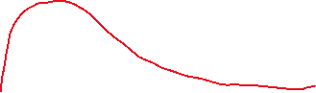

1. Draw an example of a negatively (left) skewed distribution.

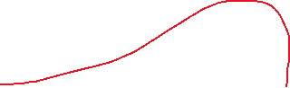

1. Draw an example of a platykurtic distribution.



1. Draw an example of a leptokurtic distribution.

