**Instructions:** Use the file ‘ByHand.csv’ to answer the following questions.

**Variable Codebook:**

* *Total_score* : Score (number correct) for a 10-item Science Test
* *Age* : Age of students
* *Height* : Height of students (in inches).
* *Time_SocialMedia* : Time Spent on Social Media (in minutes) per week.

1. Write out the formula for calculating a *z* score. (Hint: Treat the data in ‘ByHand.csv’ like a sample, not a population).
2. Using the variable *Total_score*, calculate the *z* score for a person with a score of 8. Interpret this value in words.
3. Using the variable *Age*, calculate the *z* score for a person who is 17 years old.
4. Compare the values calculated in Questions 2 and 3 in reference to their respective means.
5. Why can we compare the values in Questions 2 and 3 when they are completely different variables?
6. A *z* score is a function of two things. What are they?
7. What happens to our *z* scores when the standard deviation decreases?
8. If our standard deviation decreases, will the pattern of positive/negative *z* scores change?
9. Using the variable *Height*, calculate the raw score value for an individual with a *z* score of 2.
10. Using the variable *Height*, calculate the raw score value for an individual with a *z* score of -0.754.
11. What is the mean and standard deviation for *z* scores?
12. Are *z* scores consistent from sample to sample? Why or why not?
13. True or False: Transforming raw scores to *z* scores automatically makes a distribution normal.
14. True or False: Transforming raw scores to *z* scores impacts the shape of the distribution.
15. The normal distribution is actually a family of distributions that have the same shape (bell-shaped curve) but can differ in two main ways. What are those two main ways?
16. What is the standard normal distribution?

Use the following image to answer the following questions.

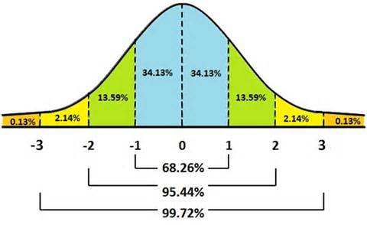

1. What is the probability of a score falling between -2 and +2?
2. What is the proportion of scores falling between -2 and +2?
3. What is the probability of a score falling below -1?