**Instructions:** Use the file ‘ByHand.csv’ to answer the following questions.

**Variable Codebook:**

* *Total_score* : Score (number correct) for a 10-item Science Test
* *Age* : Age of students
* *Height* : Height of students (in inches).
* *Time_SocialMedia* : Time Spent on Social Media (in minutes) per week.

1. Write out the formula for calculating a *z* score. (Hint: Treat the data in ‘ByHand.csv’ like a sample, not a population).
$$z=\frac{X-\overline{X}}{s}$$

2. Using the variable *Total_score*, calculate the *z* score for a person with a score of 8. Interpret this value in words.

$$z=\frac{8-5.8}{2.455}=+0.896$$

A person with a total score of 8 has a score that is 0.896 standard deviations above the mean.

1. Using the variable *Age*, calculate the *z* score for a person who is 17 years old.

$$z=\frac{17-20.2}{3.052}=-1.048$$

A person who is 17 years old has an age value that is 1.048 standard deviations below the mean.

1. Compare the values calculated in Questions 2 and 3 in reference to their respective means.

Because the *z* score associated with a total score equal to 8 is positive, we know that people with that particular total score are scoring above the mean.

Because the *z* score associated with an age of 17 is negative, we know that people of that age are of an age that is below the mean.

1. Why can we compare the values in Questions 2 and 3 when they are completely different variables?

We can compare the two values despite them being on different scales because we have standardized the values to be on a common metric of *z* scores.

1. A *z* score is a function of two things. What are they?

Where an individual falls on the distribution, relative to the mean, and the spread of the distribution.

1. What happens to our *z* scores when the standard deviation decreases?

As the standard deviation decreases, the value of the *z* scores will increase.

1. If our standard deviation decreases, will the pattern of positive/negative *z* scores change?

No, the signs would stay the same.

1. Using the variable *Height*, calculate the raw score value for an individual with a *z* score of 2.
$$z\left(s\right)+\overline{x}=2\left(6.899\right)+69.2=82.998$$

2. Using the variable *Height*, calculate the raw score value for an individual with a *z* score of -0.754.
$$-0.754\left(6.899\right)+69.2=63.998$$

3. What is the mean and standard deviation for *z* scores?

The mean is equal to 0 and the standard deviation is equal to 1.

1. Are *z* scores consistent from sample to sample? Why or why not?

No, *z* scores are not consistent from sample to sample; the same score can result in radically different *z* scores depending on the sample we are working with (remember, *z* scores are calculated using the sample mean and sample standard deviation, which will change from sample to sample!).

1. True or False: Transforming raw scores to *z* scores automatically makes a distribution normal.

False

1. True or False: Transforming raw scores to *z* scores impacts the shape of the distribution.

False

1. The normal distribution is actually a family of distributions that have the same shape (bell-shaped curve) but can differ in two main ways. What are those two main ways?

Mean (Center) and Standard Deviation (Spread)

1. What is the standard normal distribution?

The normal distribution standardized to have a mean of 0 and standard deviation of 1.

Use the following image to answer the following questions.

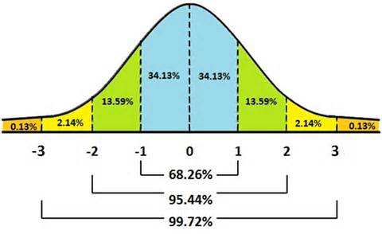

1. What is the probability of a score falling between -2 and +2?

$$3.59+34.13+34.13+13.59=95.44$$

95.44% Chance

1. What is the proportion of scores falling between -2 and +2?

0.9544

1. What is the probability of a score falling below -1?

$$0.13+2.14+13.59=15.86$$

15.86% Chance