**Instructions:** Use the file ‘ByHand.csv’ to answer the following questions.

**Variable Codebook:**

* *Total_score* : Score (number correct) for a 10-item Science Test
* *Age* : Age of students
* *Height* : Height of students (in inches).
* *Time_SocialMedia* : Time Spent on Social Media (in minutes) per week.

Click the following link and complete the following exercises.

<http://onlinestatbook.com/stat_sim/sampling_dist/>

**Playing with Sampling Distributions**

* Click ‘Begin’ towards the left of the screen.
* Click the ‘Animated’ button under ‘Sample:’. This will plot 5 points on the ‘Sample Data’ graph. It will also take the mean of these 5 points and plot one point on the ‘Distribution of Means’ graph.
* Repeat this process to see the Distribution of Means grow. Feel free to try it with ‘5’, ‘10,000’, and ‘100,000’!

1. What happens to the mean of the Distribution of Sample Means as you repeat this process?

**Understanding Standard Error**

1. The standard error is equal to the standard deviation of the sampling distribution ($\frac{σ}{\sqrt{n}}$). Assuming a standard deviation of $σ=5$, calculate:
   1. Standard Error of the Mean when $n=5$:
   2. Standard Error of the Mean when $n=10$:
2. What characteristic of our sample will influence the size of the standard error?
3. How does it affect the standard error?

**Hypothesis Testing**

We are interested in whether the population from which our ‘ByHand.csv’ *Total_score* variable comes from differs statistically significantly from a population of graduate students with an average (population mean $μ$) of 8 and standard deviation (population standard deviation $σ$) of 2 points.

Complete the six steps of hypothesis testing below.

1. Step 1: State the research ($H_{A}$) and null ($H_{0}$) hypotheses.
2. Step 2: Select the statistical test and the significance level.
   1. Statistical Test =
   2. Significance Level (Alpha) = 0.05
3. Step 3: Select the sample and collect the data.

Mean *Total_score* ($\overline{X}$) =

Sample Size ($n$) =

Population Mean ($μ$) =

Population Standard Deviation ($σ$) =

1. Step 4: Find the region of rejection.
2. Step 5: Calculate the test statistic.
3. Step 6: Make the statistical decision to reject or fail to reject the null.
   1. Compare our sample $z$ to the $z_{critical}$.
 $z=$

 $z_{critical}=$

 2. Do we reject the null or fail to reject the null? Select one of the following.
      1. Our $z$ is $>z_{critical}$, so we reject the null hypothesis.
      2. Our $z$ is $<z_{critical}$, so we fail to reject the null hypothesis.
   3. On the graph below, indicate approximately where our sample *z* score fell.

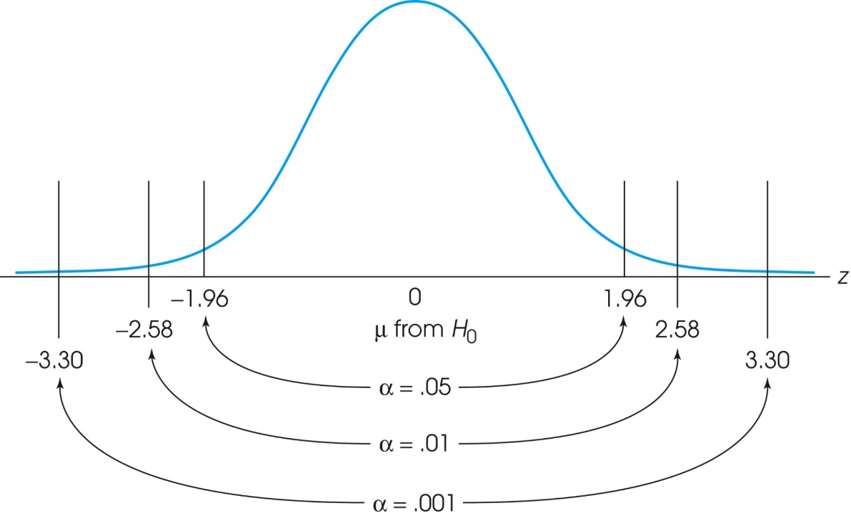

* 1. Interpret the findings in words.