**Instructions**

Using the practice dataset provided (‘SoftwarePractice.csv’), complete the following tasks using your software of choice (SPSS, R, or SAS).

**Variable Codebook**

* *TV_watching_per_week* : Number of hours a student spends watching TV per week.
* *Math_score* : Score (number correct) on a 50-Item Math Exam.
* *number_Classes_missed* : Number of classes a student has missed.
* *Num_hours_sleep* : Number of hours of sleep a student gets on a typical night.
* *Institution_type* : Type of institution a student attends.
  + 0 = Public
  + 1 = Private

You are interested in determining whether the population from which our ‘SoftwarePractice.csv’ sample data *TV_watching_per_week* variable comes from is statistically significantly different from a population of graduate students with $μ=15$ and $σ=2$. Complete the six steps of hypothesis testing

1. Step 1: State the research hypothesis ($H_{A}$) and null hypothesis ($H_{0}$).
$$H_{0}: μ=15$$

$$H_{A}: μ≠15$$

2. Step 2: Select the statistical test and the significance level.
   1. Statistical Test = One-Sample *z*-test
   2. Alpha = .05
3. Step 3: Select the sample and collect the data.
   1. Sample Size ($n$) = 1000
   2. Sample Mean ($\overline{X}$) = 9.988
   3. Population Mean ($μ$) = 15
   4. Population Standard Deviation ($σ$) = 2
4. Step 4: Find the region of rejection.

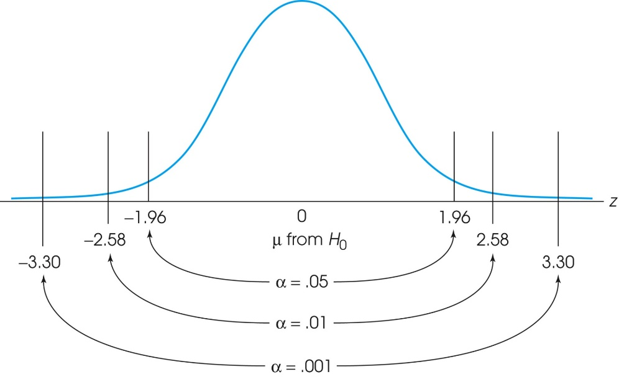



-1.96 and +1.96 for a two-tailed hypothesis with alpha = 0.05

1. Step 5: Calculate the test statistic.
$$σ_{\overline{x}}=\frac{2}{\sqrt{1000}}=0.063$$

$$z=\frac{\overline{X}-μ_{\overline{x}}}{σ_{\overline{x}}}=\frac{\overline{X}-μ_{0}}{σ_{\overline{x}}}=\frac{9.988-15}{0.063}=-79.56$$

2. Step 6: Make the statistical decision to reject or fail to reject the null hypothesis.

Our z is > zcritical, so we *reject* H0